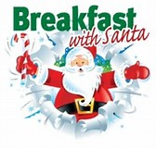
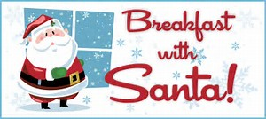

Breakfast With Santa

Exciting News!! – We have found out that the “big man” himself is able to join us for breakfast on two mornings.

- Children are invited to come to school at 8:00 AM to receive breakfast (Cereal and/or Danish pastries and a glass of juice) and meet Santa.
- Key Stage 1, Reception and Nursery children are invited on Wednesday 18th December.
- Key Stage 2 children are invited on Thursday 19th December.
- The cost of this event is £3.50 per child.

If you want your child to attend, it is essential that you book a place by filling in the form below and returning to the class teacher with the correct money no later than Friday 6th December. Also, please ensure you let us know of any allergies by listing it on the form.

Thank you

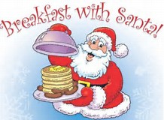
Breakfast with Santa
My child is in Key Stage 1, Reception or Nursery and I would like to book a place for my child at the Breakfast with Santa event on Wednesday 18th December

Child name ………………………………………………….. Class…………………… Allergies……………………….

I enclose £3.50

